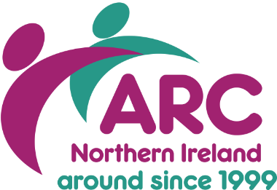
Application for Membership 2026/27

Organisation Name: Click here to enter organisation name
Name of Chief Executive (or equivalent): Click here to enter name of CEO
Head Office Address: Click here to enter address
Click here to enter address.
Click here to enter town/city. Postcode: Click here to enter postcode
Tel: tel number Website: Click here to enter web address.

About Your Organisation

Please confirm which body you are registered with? (Please tick all that apply):
Charity Commission ☐ Companies House ☐

How would you describe your organisation (Please tick all that apply):
Charity ☐ Commercial/Private ☐
Community Interest Company ☐ Public/Statutory ☐
Social Enterprise ☐

What type of service does your organisation provide? (Please tick all that apply):
Advocacy ☐ Care Home ☐
Day Care ☐ Day Opportunities ☐
Home Care ☐ Residential Care ☐
Supported Employment ☐ Supported Living ☐
Other (please specify) Other (please specify

In which Health & Social Care Trust area do you provide services? (Please tick all that apply):
Belfast ☐ Northern ☐
South-Eastern ☐ Southern ☐
Western ☐

Which of following regulatory bodies apply to your organisation and/or staff?

NISCC ☐
RQIA ☐
Other (please specify) Other (please specify)

How many paid staff does your organisation employ? Paid Staff

How many people are supported by your organisation’s services? Click here to enter text.

Of these, how many people with a learning disability do you support? Click here to enter text.
Tell us how you heard about ARC NI and what prompted you to apply?

Click her to tell us

Nominated Representative(s)
Membership applies to the whole organisation – from the CEO to frontline staff. Please indicate the name and details of your organisation’s nominated representative for the following areas of work:

NAME | JOB TITLE | EMAIL | PHONE
Senior Managers Think Tank (must be a decision maker within your organisation)
Name | Job Title | Email | Phone Number
RQIA & ARC Executive Exchange (Senior Managers level and above)
Name | Job Title | Email | Phone Number
Workforce Development (can be HR or Practice Based posts)
Name | Job Title | Email | Phone Number

ARC also facilitates three unique Peer Networks which are optional. For an additional charge of £100 per network, these specialised roles will access the support from their peers, share practice and collaborate on policy change. Please tick if you are interested in receiving the nomination forms for:

Adult Safeguarding Champions Peer Network ☐
Registered Managers Peer Network ☐
Restrictive Practice Peer Network ☐

Membership Fees
Membership year runs from April – March.  Organisations that join mid-year pay pro-rata for their annual subscription.  Membership fees are based on the organisation’s annual turnover as documented through annual accounts. It is your responsibility to notify ARC should the organisations income change. | Please tick the appropriate box:
 | Band | Turnover Level £
 | ☐ A | < £1m
 | ☐ B | £1m - < £10m
 | ☐ C | £10m+

Commitment Statement
On behalf of my organisation, I hereby apply for membership of the Association for Real Change, Northern Ireland. I authorise ARC to communicate with any relevant and interested staff who work for my organisation. I have read the section confirming what I can and cannot expect as a member of ARC NI and I have read the Members’ Commitment. I confirm that I stand fully behind the beliefs it endorses and will strive to put them into practice.

Signed: By printing your name, you are authorising this application Date: Click here to enter a date.

As an ARC NI member, your email address, including the nominated reps will be automatically added to our distribution and workstream lists where we will keep you up to date with future training and events. At any time you can remove yourself from this by emailing arc.ni@arcuk.org.uk.

What Happens Now?
Your application will be considered and communication from the NI Director will be received, followed by an invoice.

ARC NI is only as strong as its members so we look forward to welcoming your organisation’s contributions and thank you for your application.

What Members Can Expect from ARC NI
1. A strong, collaborative network
ARC NI connects members across sectors to share experiences, challenges and good practice. Members can engage with peers at all organisational levels, from CEOs to frontline staff and with regulators, policy makers and funders e.g. Supporting People.
2. Opportunities to influence policy and system change
Members receive support to participate in public consultations, planning processes and Government structures responsible for making change. ARC NI works to amplify members’ experiences to drive improvements for people with a learning disability, autism and other support needs.
3. Access to learning, development and knowledge-sharing
Members benefit from regular updates on events, training and workforce development opportunities, as well as sector insights, briefings and communications. Peer networks—such as Adult Safeguarding Champions, Registered Managers and Restrictive Practice—offer expertise to those in specialised roles (optional extra).
4. A values-driven community
ARC NI follows the values in the Commitment Statement: person-led support, cross-sector collaboration, constructive dialogue, confidentiality, and a focus on improving people’s lives.
5. Inclusion and representation
ARC NI engage with nominated representatives and relevant staff to ensure your organisation’s voice is reflected in collaborative workstreams and discussions. Membership covers the whole organisation.
6. A responsive membership service
Once membership is approved, organisations receive a welcome pack from the Director and ongoing communication throughout the year.

What Members Cannot Expect from ARC NI
1. Individual advocacy or case-specific intervention
ARC NI addresses sector-wide issues and does not provide advocacy or dispute resolution for individual organisations, staff or people supported.

2. Inspection, regulatory or legal advice
While ARC NI facilitates discussion on regulation and workforce matters, it does not offer formal legal, regulatory or compliance advice.
3. Preferential funding or commissioning support
ARC NI does not influence commissioning decisions for individual organisations, and membership does not guarantee access to funding.
4. Commercial advantage or preferential treatment
Members must set aside commercial interests when engaging. ARC NI does not promote specific organisations or act as a marketing platform.
5. Unlimited or unrestricted access to staff time
ARC NI supports networks and communication, but membership does not include unlimited consultancy, tailored organisational development, or exclusive services beyond the standard benefits.
6. Sharing of confidential information beyond agreed boundaries
ARC NI maintains appropriate confidentiality to enable open discussion but will not share sensitive information about other members or partners.

Members Commitment

ARC brings people together. We support them to share different views and experiences.
We help them to agree and take action to improve the lives of people with a learning disability, autism and other support needs.

When becoming a member of ARC you are agreeing to:
- Working together to continually improve the quality of care and support, and lives, of people who live in our communities;
- Continually developing your knowledge and practice by both learning from, and supportively guiding each other including our external partners;
- Improving policy by engaging with, leading and influencing planning processes;
- Encouraging partnerships by facilitating peer-to-peer support between your staff and others working in the community; and the people you support with others living in the community
- Respecting the boundaries of confidentiality to enable the sharing of sensitive information whilst encouraging trusting relationships

Your organisation is also subscribing to the following values:
- We believe that people should receive person-led models of support delivered by people who are enabled to continually improve and develop their skills, motivation and practice.
- We believe that the changes needed to improve the lives of people in our communities can only be achieved by all organisations, from all sectors, working together as equal partners.
- Members from all sectors (voluntary, statutory, independent) are invited as equal partners in ARC. We endeavour to hear and include views equally from all members.
- We endeavour, as far as possible, to set aside commercial or organisational interests to work collectively on behalf of the people we support.


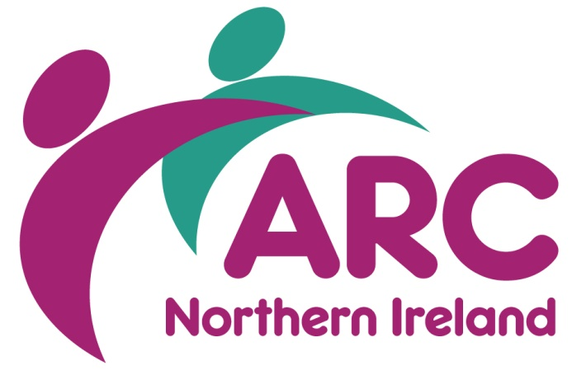
- We work openly and constructively to acknowledge and address organisational and cultural differences where they exist.
Association for Real Change, Northern Ireland
028 9038 0960
arc.ni@arcuk.org.uk
arcni.org.uk
linkedin.com/company/arcni
facebook.com/arcnorthernireland

